1. | Costs Analysis (10 Marks)
 | - Create a chart to categorize your costs associated to your Project.
 | - Identify under which category each cost would be found (Remember, a cost can be allocated to more than 1 category).
 | - Refer to the Lecture and your class notes for details
 | Costs Allocation:
- Project Manager: | $73.00 Regular time
 | $109.50 Overtime (after 44 hours/week)
- Team Member: | $39.50 Regular time
 | $59.25 Overtime (after 40 hours/week)
- Manufacturing Costs: | $4.65/hr (Factory Utilities, Space Leasing, etc.)
 | $2.15/hr (Upkeep and Maintenance, Snowplowing, Repairs, etc.)
- Benefits Costs: | $3.25/hr (Health Insurance, Uniforms, Retirement, etc.)
- Mandatory Breaks: | $0.61/hr (Worked per Employees)

 | Labour Calculation & Costs Chart Example:
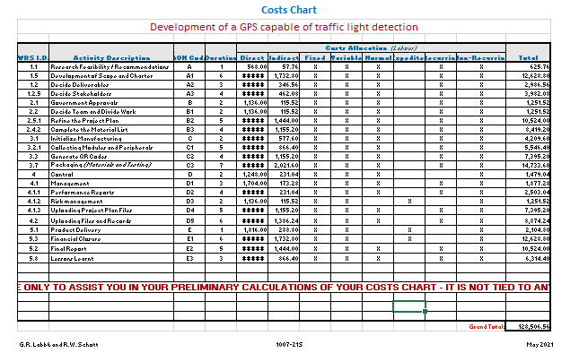
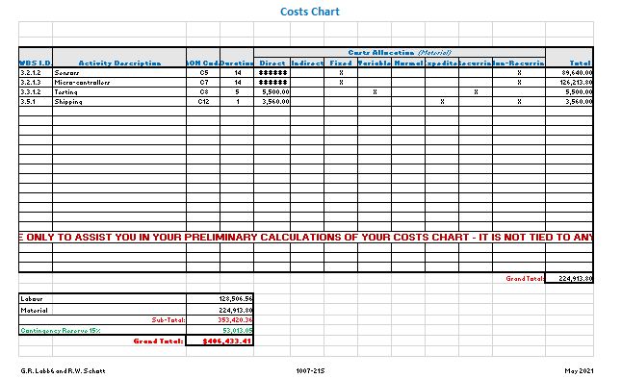

 | Marking Table:
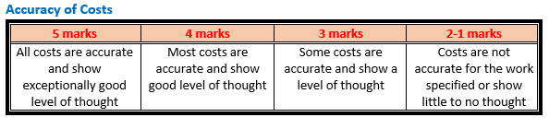
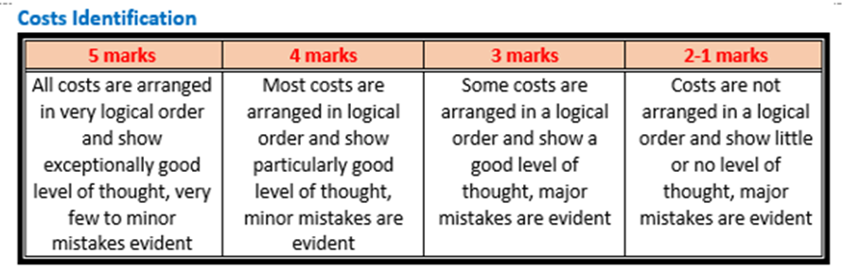

 | 